Persinger Casimir Papers:

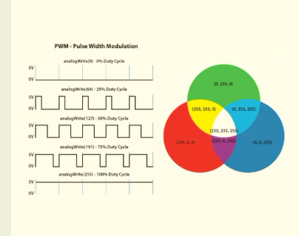

Hameroff (2015, SPIE): Such “sol-gel transitions” which can occur as rapidly as 40 times per second [.025/s] account for intracellular flow of cytoplasm (e.g. “amoeboid movement). Because actin surfaces are negatively charged, in the gel phase nearly all polar cell water molecules are bound and “ordered”. Thus, during the gel phase, the view of cell interiors as a “minestrone soup” of floating organelles is incorrect. Rather, cytoplasmic gel is a quasi-solid state medium. [also see Bose Condensate in paper, reference to Persinger Bose comments]

at around 1:07 timestamp of ‘Montauk Chronicles’ (C. Garetano 2014) documentary there is a an accurate description of entanglement technology as written of by Persinger and others. Including an example which seems to relate to using the Zeeman effect to triangulate. Scifi: a search was underway to find the colonies. In Stewart Swerdlow testimony, self-account of teleportation experiments backward in time. Also see Preston Nichols and Al Bielek. Nichols, ‘The Montauk Project: Experiments in Time’ (1992) predates any public experiments with this technology. ‘Montauk: The Alien Connection’ (1998) by Stewart Swerdlow https://www.expansions.com/

is most activity of eeg from start point, input like T3, or F7 (left/right) if input is targeting left side then you feel it from the left, if right then you feel it from the right? To accentuate the effect add a directional sensed presence. Like looking up to the right seems to be a Machine correlate, or looking out to ‘someone’ to the left for adversarial theatre characters.

----------------

Research Article Effect of Near-Infrared Pulsed Light on the Human Brain Using Electroencephalography Yi-Chia Shan , 1 Wei Fang , 1 Yang-Chyuan Chang , 2 Wen-Dien Chang , 3 and Jih-Huah Wu 4 (2020)

Low Level Light Therapy (LED application)

Applies to the skin question as well, used LED directed at skin on palms of hands to alter Alpha oscillations in the human brain.

LED (incoherent light) is as effective as laser (coherent light)

“In this experiment, the average
PSD of the subjects in the parietal and temporal cortex
locations during session 3 was increased and shifted toward
lower frequencies in comparison with the rest stage in
Figure 4. ,e phenomenon was caused by LED stimulation
which was operated at 10 Hz. ,e normalized alpha activity
rapidly increased during and after LED stimulation in the
LED group in Figure 5. ,e affected regions were the occipital,
parietal, and temporal regions. LED stimulation
exerted a latent effect on alpha rhythm. ,e effect could
persist for at least 15 minutes after LED ceased. Based on the
experimental results, LED stimulation at the palm has an
effect to induce alpha rhythm activity, and the affected regions
were distributed in posterior. ,e influence was like
AVS, but the latent time was longer. In the control group, no
significant variation in alpha rhythm was observed.” pg. 8

Furthermore, the therapeutic window for inducing specific
brainwaves via light stimulation has been found. We believe
that the results in this study have practical implications in
the medical field. For instance, using a higher dose (or
frequency) of light stimulation may have the potential application
in enhancing the attention of students. Conversely,
using a low dose of light stimulation may improve the sleep
problems for people who have insomnia.
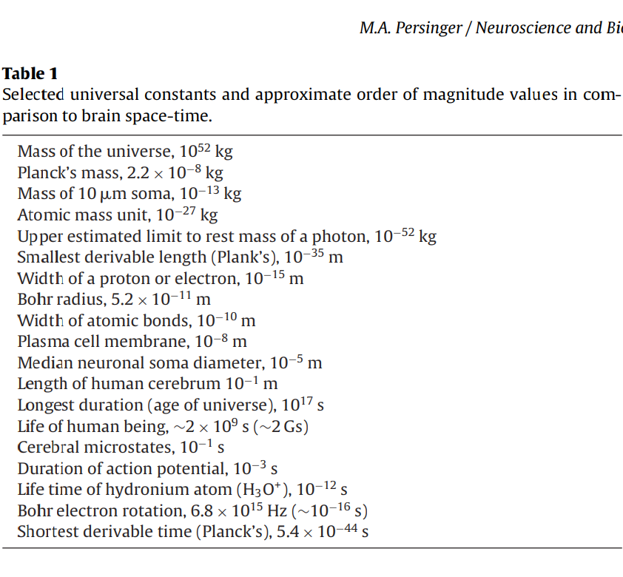

2010

Volume 2, Issue 1, 2010 The Casimir Force Along the Universal Boundary: Quantitative Solutions and Implications Stanley A. Koren, Senior Technologist, Laurentian University, SKoren@laurentian.ca Michael A. Persinger, Full Professor, Laurentian University, mpersinger@laurentian.ca

casimir pressure for two spheres at the length of 54 micro meters gives a wavelength 5.55 THz would be continuously emitted at energies in the order of 10 times greater than frequencies adjacent to this resonance. Virtual particles or zero point energy (zpe) production from the vacuum.

----------------------------------

Journal of Consciousness Exploration & Research| October 2010 | Vol. 1 | Issue 7 | pp. 785-807 Persinger, M. A. & Lavallee, C. F. Theoretical and Experimental Evidence of Macroscopic Entanglement between Human Brain Activity and Photon Emissions: Implications for Quantum Consciousness and Future Applications ISSN: 2153-8212 Journal of Consciousness Exploration & Research Published by QuantumDream, Inc. www.JCER.com 785 Focus Issue: Quantum Brain/Mind/Consciousness 2010 (Part I) Article Theoretical and Experimental Evidence of Macroscopic Entanglement Between Human Brain Activity and Photon Emissions: Implications for Quantum Consciousness and Future Applications Michael A. Persinger* & Christina F. Lavallee

The Bohr magneton (µB) for the magnetic moment of an electron can be considered a central source for macroentanglement as well as its microscale manifestations.

The magneton is the circulatory current created by the angular momentum of an electron moving in its orbit. This fundamental constant is 9.28 x 10-24 Am2 or J/T. According to some solutions for wave mechanics, the spin of an electron, the rotation around its own axis, is also exactly one Bohr magneton.

In quantum theory the spin angular momentum or spin is parameterized to the spin quantum number which is the fourth of four numbers employed to describe the unique state of an electron. The fourth quantum number has been linked to determining the locations of matter within a frame of reference. According to Hu and Wu (2006) two interacting quantum entities such as two electrons, become entangled with each other through spin processes by exchanging one or more entangling photons.

The occurrence of a quantitative value for spin predicts a potential range of energies within brain space within which consciousness and thinking occurs. For a magnetic field of 70 pT or 7 x 10-11 T the energy would be the product of this value and the spin moment or 6.624 x 10-34 J. This is equivalent according to a frequency (once divided by Planck's constant of 6.624 x 10-34 J s), of about 1 Hz. For intensities within the 100 to 200 pT range, well within the expected operating intensity of some cerebral functions, the frequency range would span 10 to 40 Hz. This quantitative convergence suggests that the processes associated with thinking could be coupled to the intrinsic characteristics of the electron from which quantum and entanglement phenomena emerge.

The numbers of revolutions per second for an electron in a Bohr magneton is 6.8 x 1015 per sec; consequently one complete rotation or completion of a single cycle requires the inverse value or 1.5 x 10-16 s. 2.2 Photon Interaction By comparison, the time required for a photon moving across a neuronal membrane of 10-8 m (10 nm) in brain space at 2 x 108 m/s would be about 10-16 s. The neuronal membrane is the source of the action potential whose composites are likely sources of the states of consciousness and thought. The convergence of 10-16 s for both the photon passage and the single rotation of a Bohr electron would be sufficient for the energy and the information within the photon to be represented within the single cycle or one closed loop of the electron's revolution.

y. The group velocity of photons will differ from the phase velocity which means that information can be stored within quantum phase differences. Group velocity refers to the singular “steady” value for the entire wave envelope within which the different complex components can display phase (temporal) shifts. Ahn et al, (2000) have suggested that information can be stored and retrieved through quantum phase shifts.

Secondly, the nonzero mass would allow a third state of polarization in which, in addition to the classic perpendicular orientations for the magnetic and electric field components of the electromagnetic wave with respect to its direction of movement, there would be the emergence of a longitudinal photon (Tu et al, 2005). This can allow individual photons to carry angular momentum of multiples of h/2π with superimposition of these eigen states (Vaziri, et al, 2002). Hence, there would be greater degrees of freedom and factorial combinations that enhance the potential for entanglement.

Experimentally, entanglement between two spins in an antiferromagnetic solid can be affected by the external magnetic field. Increasing the field strength to certain values can create entanglement between otherwise disentangled spins (Arnesen, et al, 2001).

In general the pT range would include most of the most important frequencies of small (action potential) and large scale (steady potentials in the mHz range) brain function.

. The Bohr magneton, with a magnetic moment of 9.28 x 10-24 Am2 or J/T, lays at the basis of quantum mechanics and the concept of entanglement (Aczel, 2002).

The occurrence of the Zeeman effect and the mechanism responsible for it has relevance for macroentanglement and consciousness. First it indicates that the application or presence of an external magnetic field within which systems are immersed results in shifts in functional location of states that were initially superimposed or occult. Their hyperfine differences only become evident with the application of or immersion within the magnetic field.

[see Norseen references on Zeeman effect, he considered it important to his work]

If macrocosm reflects microcosm, even in a non-specific manner, the hyperfine structure of the emergent appearance of two (and sometimes three) lines in atomic spectra should have an analogue within consciousness. The concept of transient inductions of a “second consciousness” or parasitic consciousness was proposed by Hughlings Jackson more than a century ago to explain the experiences of partial complex epileptic patients with foci in the temporal lobes (Bancaud et al, 1994). T

s. Changes in the electromagnetic fields associated with the sensed presence could affect the state of the electromagnetic fields associated with the sense of self and visa versa during transient conditions when they are separated. Consequently either the sense of self or the sensed presence could exist transiently in different spatial locations and potentially respond to information within these distinctly different and separate locations.

There is quantitative support for Zeeman phenomena within brain space even for magnetic field strengths within the operational pT range of cerebrum. The change in angular frequency with an applied field of 40 x 10-12 T would be, according to classic Zeeman formula solutions, the product of 4 x 10-11 T * 1.6 x 10-19 As divided by 12.56 * 9.1 x 10-31 kg or about 0.6 Hz. However in non-angular systems it would be 7 Hz

The increment of 10-20 J was found to be the unit associated with membrane-linked photon emission from the plasma membrane of the cell, the energy at binding sites for phosphorylation during posttranslational modifications of proteins, and the actual shift in wavelengths during bioluminescence. Such quantitative commonality would suggest an underlying physical process to which all chemical reactions that cause or are strongly correlated with brain function are related.

Consequently an electron is donated and received about once every 5 to 20 ms or on average every 12 ms (Alberts, et al, 2002). This interval is almost precisely the phase modulation associated with electromagnetic fields associated with consciousness (Llinas and Ribardy, 1993).

“5ms is the largest tangent universe timelength” says Michael

3.2 Entanglement of Thoughts for Two People?
Our first demonstration of macroentanglement involved a relatively simple paradigm. It was based upon the results of an experiment (Persinger et al, 2003) involving siblings. In that study the brain of one sibling was exposed to magnetic fields that were pulsed for various durations as they rotated counterclockwise from each of 8 equally spaced solenoids placed around the person’s head. We employed the counterclockwise direction because we presumed the direction of the field would be moving against the rostral-caudal creations of the natural macroscopic magnetic fields generated from the cerebrum. This would produce the interference patterns sufficient to influence the temporal recreation of consciousness.

This rotational direction had significantly affected subjective time distortion (Cook et al, 1999); the duration of the total time distortion was a function of the numbers of rotations. Special subjects who were involved with verifiable “remote viewing” showed measurable improvements of these capacities during the days following exposures to the rotational fields. Ingo Swann’s (Persinger, et al, 2002) accuracy for information concerning stimuli at substantial distances from his brain was strongly correlated with the durations of unusual 7 Hz spike like waves over his right hemisphere during the “viewing” process.

We asked the question: if consciousness was “recreated” within the transcerebral electromagnetic fields once every 10 ms to 20 ms then what occurs in that finite but very small duration of time between the end of one transcerebral electromagnetic field and the beginning of the next? What occurs during the “infinitesimal infinity” of that interval?

Consequently the circumcerebral device was tuned to overlap with the temporal characteristics of the emergent processes, in the order of 20 msec, associated with consciousness. The rate of rotation of the 0.5 to 1 µT magnetic fields in this horizontal plane just above the ears (from an external perspective) could be programmed to accelerate or de-accelerate. Although a constant velocity in a circle is technically also always accelerating, we designed the experimental apparatus to produce consistently changing angular velocities. Applied field strengths in the order of 1 µT (10 milligauss) are usually considered too small to compensate for many of the thermal-related processes within cerebral space. However the penetrability of the magnetic fields within this constrained volume allows for potential storage of energy which can be estimated by J=[B2 /(2* 4π µ)+ * m3 where B is the field strength, µ is magnetic permeability and m3 is the volume. The potential energy within a volume of about 10-3 m 3 (the human brain) would be about 10-9 J. If one assumes each of the approximately 1010 cerebral cortical neurons are firing on average at 10 Hz and each action potential involves an energy quantum of 10-20 J, then this applied strength would be sufficient to interact with the average energy display from electromagnetic activity of the entire cortices.

CASIMIR
There are three main consequences of these assumptions. First, material boundaries polarize the vacuum of a quantitized field such that the force acting on the boundary is a result of polarization. Second, the application of external fields create particles from the vacuum because energy is transferred by the external field to virtual particles (vacuum oscillations), thus transforming them into real particles. Third, and important for the experimental production of these effects, there is no effect with static boundaries. If the boundary conditions are changing as a function of time, there is particle creation as well as the production of a force.

The formula for the Casimir force is: (π² /240)* (ħc/a⁴ ) S, where ħ is the modified Planck’s constant, c is the velocity of light, a is the distance of separation between the two plates and S is the area. The Casimir force across the synapse with distance between the two "plates" of about 10 nm would be (.014 * 1.06 x 10-34 Js * 3 x 108 m/s)/(10-8m)4 . Assuming the maximum width of a synapse is 2 um and is square-shaped the area would be 4 x 10-12 m 2 , the force would be .52 x 10-6 N and when applied across 10-8 m the energy would be .52 x 10-14 J.

4.4 Accessing Zero Potential Energy
The energy associated with ZPF or Zero Point Fluctuations is *π c5 ħ)/(4G)+1/2 or about 2.8 x 109 J or 1.7 GeV. The voltage associated with that energy is J/q or 2.8 x 10-10 V. The classic frequency of 40 Hz associated with consciousness is associated with 264 x 10-34 J. The magnetic field strength sufficient to affect the spin magnetic moment of 9.78 x 10-24 J/T would be 27 x 10-10 T (about 3 nT). The area associated with this magnetic field strength, electric field, and frequency according to m2 =V/fB is 5 cm which is average radius of the human cerebrum.
From this perspective spaces with radii in the range of the human cerebrum could have access to the energy associated with the zero point fluctuations (Puthoff, 1989). The frequency associated with the Zitterbewegung (ZPF or “jitter”) can be calculated from π c5 /ħG or 3.30 x 1043 Hz. The square root of this value is 5.7 x 1021 √Hz. When multiplied by Plank’s constant to the resulting value is 3.8 x 10-12 J √s. If we assume the frequency density of the cerebrum is within the 100 Hz range, then multiplying by the square root of this value √100 1/s) results an intrinsic energy of about 3.8 x 10-11 J. Consequently the energy for the entire brain resonance of 100 Hz (or 10 ms increments) would be within the range generated by a 100 million neurons firing around 10 Hz.

4.6 The Problem of Entanglement from the Future
….
This concept is congruent with the boundary condition of Nyquist limits applied to the relationship between ∆s (an increment of space) and ∆t (an increment of time). In the perception of physical phenomena as functional wholes, there is an intrinsic correlation (Persinger, 1999). To view picometer space one requires a minimum increment of picosecond time; to view millimetre space one requires millisecond time. However to perceive process there must be at least two successive ∆ts. The upper limit occurs with the maximum possible ∆s, the universe, and the maximum ∆t, the age of the universe. At this perspective, there is no process and no time, but only a static, non changing single unit

The most likely (known) moderating process for such transtemporal connection would be the photon. It may not be coincidence that the energy associated with the age (or frequency) of the universe, about 4 x 1017 s would have a value of 6.6 x 10-34 J s * .24 x 10-17 Hz or about 2 x 10-51 J. This value is remarkably similar to the upper limits of the rest mass (about 10-51 kg) of a photon which is a quantity expected following the removal of c2 from the relationship. One interpretation of this apparent identity is that the energy contained within a photon with a velocity near c contains the information of and a connection with the age of the universe and supports the assumptions of quantum philosophy (Horgan 1992) and Hu and Wu (2006).

4.7 The Involvement of Gravitational Energy with Consciousness
Calculations by Ahmed et al (1997) indicated the effects of gravity (as inferred by weightlessness) on the human EEG, assuming axon conduction of about 20 m/s, was about 2 parts per million. However with 4 m/s, the bulk velocity associated with the cerebral cohesive waves that results in about 7 Hz for its fundamental resonance (f[n(n+1)/2]1/2 * v/2πr (where cerebral circumference is about 55 cm), the value would be about 2 parts per 10 million. This means that if we assume the transmission is by hydrogen (90% of the universe) with a peak emission of 1.42 GHz (21 cm) one complete phase shift from one peak to the next would require 2 x 107 divided by 1.42 x 109 1/s (Hz) or about 14 msec. This would suggest that processes associated with gravity could affect the phase modulation of cerebral activity.

The most powerful amplification region for gravity-to-electromagnetic conversion occurred within the second global Schumann resonance of about f=14 Hz. In this frequency band detection of gravity waves was increased by an order of magnitude.

Phase modulation, which has been considered the most optimal means to propagate the most information over distance, is obtained by time divided by √*v2 /c2 ]. Because most of the electromagnetic fields associated with lightning are between 10 kHz and 100 kHz (atmospherics), the ∆c/c is .05 according to Tu et al (2005). This means the phase shift for every second is 1/.9897 or 16 ms. This value is congruent with the phase comparisons of approximately 10 to 20 ms associated with the continuous 40 Hz oscillations over the entire cerebral mantle (Llinas and Ribary, 1993). Such convergence sets the conditions for resonance exchange of information between the cerebrum and the geophysical, electromagneticgravitational environment.

Schlegel and Füllekrug (1999) found that during strong solar proton events with durations between about 3 days to 3 weeks, the amplitude of the Schumann resonance increased by about 0.2 pT (range =-0.1 to +0.4 pT) while the frequency increased between 0.05 Hz to 0.14 Hz.

The increase in intensity, when multiplied by Planck’s constant would be equivalent to energy with a frequency of about .28 x 10-2 Hz or 2.8 mHz. This is within the range of resonant oscillations (with amplitudes in the order of 0.5 nGal or 5 x 10-12 m/s2 ) between the earth and the atmosphere as recorded by Nishida et al (2000). For a human weighing 70 kg this would be a force of 3.5 x 10-10 N and with cross section of .25 m2 the resulting pressure would be 5.8 x 10-9 Pa. When applied to the person's volume the energy would be 4 x 10-12 J which is equivalent to about 2 x 10-11 W/m2 . This is within the range of the photon output from the right hemisphere of volunteers while they were thinking of white light (Dotta and Persinger, 2010). If we know the energy then we can calculate the equivalent magnetic field (B2 =Jµ2/m3 ). It would be about 12 nT which is within the range of the changes in the earth’s magnetic field surrounding a person who displayed a history of potential entanglements between his experiences and those of others (Persinger, 2010b).

That the value of G itself might be correlated with geomagnetic activity has been measured. Vladimirskii & Temuryants (1996) found that during periods of minimum geomagnetic activity the values for G were higher.

-----------------------------------------------------------------

2011

----------------------------------------------------------------

Journal of Cosmology, 2011, Vol. 14. JournalofCosmology.com, 2011 Electromagnetic Bases of the Universality of the Characteristics of Consciousness: Quantitative Support Michael A. Persinger, Ph.D.

skipped over, similar to 2010 papers.

---------------------------------------------------------

2012

Neuroscience and Biobehavioral Reviews 36 (2012) 2334–2338 Contents lists available at SciVerse ScienceDirect Neuroscience and Biobehavioral Reviews journal hom ep age: www.elsevier.com/locate/neubiorev Review Solutions for real values in Minkowski four-dimensional space may link macroand micro-quantum processes in the brain Michael A. Persinger

skipped, repeated material.

-------------------------------------------------------------

Michael A. Persinger and Christina Lavallee The n=n Concept And the Quantitative Support for the Cerebral-Holographic and Electromagnetic Configuration of Consciousness 2012

). Gabor wavelets are considered the bases of the interference patterns, as a result of refracted waves and a coherent background wave, that store both amplitude and phase (Pribram, 1971). One possible neurobiological equivalent might be the interference ‘waves’ produced by myriad action potentials superimposed upon the coherent steady potential background wave like that associated with microstates (Koenig et al., 2002).

The antithetical position of a unit (a bit) versus a process (a wave) is more likely to be analogous to the apparent contradiction that existed for light as a particle or wave. If becoming aware of our conscious experience is due to the delay of an incoming pattern before it is matched with a previously established structural pattern of organization (‘memory’), as suggested by Pribram and Meade (1999), there would be little contradiction. In fact it would accommodate the simultaneous representation of the modal frequency (40 Hz) associated with consciousness upon the slower theta (5 to 7 Hz) waves associated with memory consolidation within the hippocampus (Lisman and Idiart, 1995). This coupling has been measured at very global levels where theta-gamma phase synchronization occurs during memory matching (Holz et al., 2010).

. If this range in width were considered electromagnetic wavelengths (500 nm to 2000 nm) they would overlap with the visible and near infrared frequencies of photons. pg. 3.

Di Biase (2009)

he hippocampal formation (Bischofberger et al., 2006). There are several implications directly relevant to consciousness for this structure-based determination of the 20 to 30 msec ‘circuit’ time. First, if consciousness in the human sense requires this timing, then the different sized brains that define other animals might not satisfy this condition in the same manner. Secondly, non-carbon systems, such as silicon-based computer pathways, that involve this timing for very complex circuits, might be capable of approaching the critical criterion.

The quantitative convergence between the energy contained within our applied magnetic fields and that generated by the EM component of neuronal activity indicates a quantitative threshold is present. However, to interact with the cerebral hologram the applied magnetic field should interact with the boundary of the hologram. Applications of transcerebral magnetic fields across the brain at the level of the temporal lobes have been shown to produce reliable changes in sensory and cognitive experiences. pg. 18

However, application geometries that create more cerebrally inclusive fields that rotate in a counterclockwise direction around the skull, such that interference patterns are more likely to be generated within the right hemisphere between the rostral accelerating circumcerebrally applied fields and the rostral-to-caudal phase modulations of 20 msec within the cortical manifold, produce more profound changes in consciousness. Accelerating or de-accelerating magnetic fields with angular values for variable velocity and acceleration are associated with profound effects on consciousness and the awareness of this state (Tsang et al., 2004; Booth and Persinger, 2009) pg. 18

The application of the external magnetic field creates a boundary that polarizes the cerebral field such that particles would be created from the vacuum (Bordag et al., 2001). Energy is transferred by the external field to virtual particles thus transferring them into real ones that can emerge within the cerebral holographic field and hence modify consciousness. There is no effect with static boundaries. When the boundary conditions change as a function of time, there is particle creation in addition to the force over distance or energy. A circularly rotating magnetic field, which is technically always accelerating, with the addition of temporal derivates created by successive shifts in the angular velocity, are the optimal application of this concept. PG. 19

--------------------------------------
The Open Astronomy Journal, 2012, 5, 41-43 41 1874-3811/12 2012 Bentham Open Open Access Potential Origins of a Quantitative Equivalence Between Gravity and Light Michael A. Persinger*

--------------------------------------------------------------

2013

NeuroQuantology | March 2013 | Volume 11 | Issue 1| Page 1-7 Burke RC and Persinger MA., Hippocampus and Singularity www.neuroquantology.com 1 Articlex Convergent Quantitative Solutions Indicating the Human Hippocampus as a Singularity and Access to Cosmological Consciousness Ryan C. Burke and Michael A. Persinger

The human brain is the matter within a volume that may contain properties that facilitate the transformation of virtual particles existing at the level Planck’s length to actual matter. As indicated by Bordag et al. (2001) an infinite vacuum energy of quantized electromagnetic field in free Minkowski space can be shown to allow a finite force between two parallel neutral plates. This Casimir force involves the existence of zero-point oscillations which are associated with the point values of a quantized field. Boundaries composed of matter polarize the vacuum of a quantized field. The energy over distance is a consequence of the result of vacuum polarization by an external field.

-----------------------------------------------------------------

Predicting random events from background photon density two days previously: implications for virtual-to-matter determinism and changing the future David A. E. Vares1 and Michael A. Persinger1 1 Bioquantum Laboratory, Laurentian University, Sudbury, Ontario, Canada, P3E 2C6 Tel: 01-705-675-4824; Fax: 01-705-671-3844 E-mail: dx_vares@laurentian.ca and mpersinger@laurentian.ca 2013

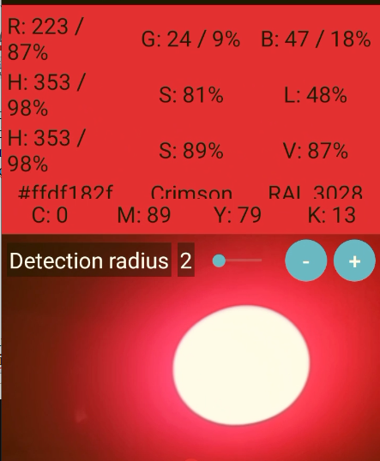

----------------------------------------------------------------

International Journal of Geosciences, 2013, 4, 1321-1325 Published Online December 2013 (http://www.scirp.org/journal/ijg) http://dx.doi.org/10.4236/ijg.2013.410127 Open Access IJG The ~3.6 to 3.7 M Paucity in Global Earthquake Frequency: Potential Coupling to Zero Point Fluctuation Force and Quantum Energies David A. E. Vares, Michael A. Persinger

“...connectivity to Kaluza- Klein configurations [4] and physical coupling to gravity [5] and the Zero Point (Fluctuation) Force (ZPF) of the vacuum. As aptly stated by Puthoff [6] and Sakharov [7] gravity is not a separately manifesting fundamental force but an induced effect associated with ZPF within the structure of space (the “vacuum”). One type of expected vacuum quantum effect is the creation of particles from the vacuum condition [8]. If energy is transferred from an external field to vacuum oscillations, these “virtual particles” can emerge in macrospace as real increments of mass. Conversely, in a dynamic context where New- ton’s Third Law, for every force there is an equal and opposite force, is operative, “real” particles could be immersed into their virtual representations. A similar concept was developed by Sir Arthur Eddington [9] dur- ing the early 20th century.”

Sytinskij found that earthquakes preceded geomagnetic activity by 1 or 2 days. This relationship would be more consistent with a change within the shared Planck space-time and intrinsically gravitational associated zero point fluctuation force transiently occu- pied by the solar system as it moves through the galaxy. From this perspective, the temporally discrepant elici- tations of the terrestrial and solar releases of energy sim- ply reflect their differential latencies to this third factor. There are new approaches to consider the effective cou- pling of gravity to matter [15] and sufficient mathemati- cal models that could test the predictions of topological transitions and large-scale space-time structure for those multidimensional theories of gravity [4,5]. The existence of this connection could also accommodate some of the anomalies, namely the “stochastic fluctuations” of the dynamo driving parameters for the coupling between the minimum-maximum of the Sun’s activity and the mean- field dynamo [16].

Interestingly, for at least two recent M > 8.0 earthquakes (Chile and Japan) several thousands of km away, we have measured marked increases in typical photon emission flux densities (~5 × 10−11 W/m2) from the ground, by between a factor of 10 to 50 times, about two weeks before those seismic events [22].

-------------------------------------------------------------------

2014

International Letters of Chemistry, Physics and Astronomy 20(2) (2014) 160-165 ISSN 2299-3843 Relating Casimir to Magnetic Energies Results in Spatial Dimensions That Define Biology Systems Michael A. Persinger Laurentian University, Sudbury, Ontario P3E 2C6, Canada E-mail address: mpersinger@laurentian.ca 2014

The relationship between Casimir energy and magnetic energy reveals one possible relationship by which energies likely derived from vacuum fluctuations or a strong correlate could relate to the most fundamental spatial parameters within biological systems: the widths of the synapse and the ion channel
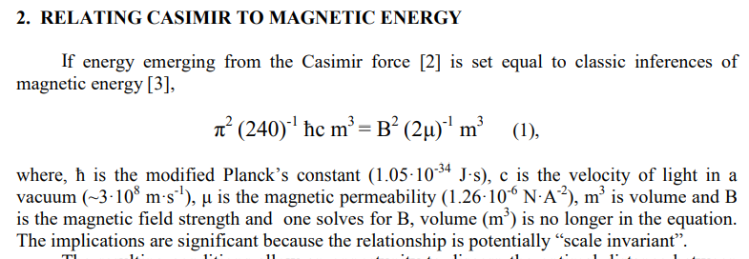
The magnetic moment of the circulating current created by an electron moving in its closed path is 9.274·10-24 A·m2 (J·T -1 ). Hence the required magnetic field strength would be the ratio or 1.01·10-1 T. If the square of that value (1.02·10-2 T 2 ) is inserted into equation (2), the optimal separation between ideal parallel plates would be ~24 nm. Application of the central limit theorem and assuming the typical standard deviations of ~30 % of the central tendency, the range for 95 % of the spaces would be between 10 and 37 nm. This is the range of the width of a synapse, the interface between neurons [4].
On the other hand if the magnetic moment of the proton (1.41·10-26 A·m2 ) is employed, the magnetic field strength required to obtain the energy associated with the hydrogen line is 6.67·101 T. If this value squared (44.5·102 T 2 ) is inserted into equation (2), the resulting width (a) is 0.93·10-9 m. This is within the median range of the width of an ion channel found in plasma cell membranes [5]. Most “channels” within the plasma cell membrane are those that mediate the movements of protons [6].

From this perspective the relationship between the times required for an electron to complete one orbit in a Bohr atom and the velocity of light become directly applicable. For a photon displaying a vacuum velocity or its mild modifications in matter such as water (2.8·108 m·s-1 ), the time required to traverse a plasma cell membrane (~10-8 m) would be ~10- 16 s. Such temporal juxtaposition could allow an interaction, such as the potential superimposition of information, between the photon and the value for the single electron orbit which is a component of the basis of Planck’s constant.

Compared to a unit Hz for Planck’s constant the energy from accelerating a photon with this upper limit of rest mass is about 8π less. For the value to be exactly 8π, the upper limit of the rest mass of a photon must be 2.93·10-52 kg. The involvement of this parameter reiterates the potential connection between components associated with cosmological constants and local phenomena. It also suggests that the second derivative of the rate of change of the surface of a sphere may help relate the shared origin of the photon and the electron.
Although more precise instrumentation will be required to verify this prediction, the implications that the photon displays a rest mass allows the emergence of a third state of polarization (where the vector of the electric field points along the line of motion), the phase shifting of electrons diffracting around a tubular magnetic flux (such as an ion channel) due to the presence of the vector potential A, and the direct influence of the Casimir phenomena upon massive photons [8].

see ref 10 M. A. Persinger, Neuroscience and Biobehavioral Reviews 36 (2012) 2334-2338

In other words the small discrepancy that has been known for decades between the magnetic moment for the spin-orbit difference for an electron and the magnetic moment of a proton could reflect a universal connection. Only when this diminutive increment of magnetic moment is multiplied by a magnetic field intensity that would allow the convergence with the energy of the neutral hydrogen line does the resulting distance merge with the wave form of the electron: the Compton wavelength. Such a large magnetic field could appear to be non-rational.
However such a field if it occurred transiently would be associated with energy. For the energy of the mass equivalence of an electron (8.28·10-14 J) to occur according to the right component of equation 1, the volume would be 2.72·10-24 m 3 or the linear radius of 14 nm or the diameter of 28 nm. This is the same functional distance as the area within which Casimir-electromagnetic energies would interact when the angular momentum of the (orbital) electron is solved for energies required from the hydrogen line.

For comparison the increment of voltage associated with the opening of a single channel in a plasma cell membrane is ~0.3 μV [4] and the energy on a unit charge would be 4.8·10-26 J or the equivalent of 3.48·10-3 °K. This has the potential to be within the range of a functional “Einstein-Bose condensate”. If this is correct then what is measured at the level of the individual ion channel should be reflected in the macrostructural physical characteristics of the brain [12].

Subtle differences in the magnetic moments for the electrons spin and orbit, the proton’s value and the slight discrepancies revealed features that could connect fundamental features of astronomical phenomena with those that contribute to quantum processes in the physical and chemical systems that define the brain.

---------------------------------------------------

Journal of Signal and Information Processing, 2014, 5, 143-154 Published Online November 2014 in SciRes. http://www.scirp.org/journal/jsip http://dx.doi.org/10.4236/jsip.2014.54017 How to cite this paper: Rouleau, N. and Persinger, M. (2014) Cerebral Networks of Interfacial Water: Analogues of the Neural Correlates of Consciousness in a Synthetic Three-Shell Realistic Head Model. Journal of Signal and Information Processing, 5, 143-154. http://dx.doi.org/10.4236/jsip.2014.54017 Cerebral Networks of Interfacial Water: Analogues of the Neural Correlates of Consciousness in a Synthetic Three-Shell Realistic Head Model Nicolas Rouleau, Michael Persinger*

-------------------------------------------------------------------

Photon emission from melanoma cells during brief stimulation by patterned magnetic fields: is the source coupled to rotational diffusion within the membrane? Blake T. Dotta1 , Robert M. Lafrenie1,2,3, Lukasz M. Karbowski1 and Michael A. Persinger Gen. Physiol. Biophys. (2014), 33, 63–73

------------------------------------------------------------

2015

Journal of Consciousness Exploration & Research| September 2015| Volume 6 | Issue 9 | pp. 658-755 ISSN: 2153-8212 Journal of Consciousness Exploration & Research Published by QuantumDream, Inc. www.JCER.com Journal of Consciousness Exploration & Research Volume 6 Issue 9 Experimental Production of Excess Brain Correlation Across the Atlantic Ocean & Other Important Results Focus Issue Featuring Michael A. Persinger Group’s Latest Breakthroughs

-------------------------------------------------------

International Letters of Chemistry, Physics and Astronomy 3 (2015) 84-105 ISSN 2299-3843 Magnetic Fields Generated By Optical Coupler Circuits May Also Be Containment Loci for Entanglement of P-N Junction-Plasma Cell Membrane Photons Within Exposed Living Systems Stanley A. Koren1,a , W. E. Bosarge2,b , Michael A. Persinger1,c

----------------------------------------------------------

Entropy 2015, 17, 6200-6212; doi:10.3390/e17096200 entropy ISSN 1099-4300 www.mdpi.com/journal/entropy Concept Paper Thixotropic Phenomena in Water: Quantitative Indicators of Casimir-Magnetic Transformations from Vacuum Oscillations (Virtual Particles) Michael A. Persinger

-------------------------------------------------------------

2016

I S S N 2347 - 3487 V o l u m e 1 1 , N u m b e r 8 J o u r n a l o f A d v a n c e s i n P h y s i c s 3947 | P a g e c o u n c i l f o r I n n o v a t i v e R e s e a r c h M a y 201 6 w w w . c i r w o r l d . c o m The Product of the Calculated Impedance and the Capacitance of the Universe Solves for Planck’s Time and 8π Michael A Persinger and Stanley A. Koren Laurentian University, Sudbury, Ontario, Canada P3E 2C6 mpersinger@laurentian.ca; SKoren@laurentian.ca

---------------------------------------------------------

l o f A d v a n c e s i n P h y s i c s 4058 | P a g e c o u n c i l f o r I n n o v a t i v e R e s e a r c h J u n e 2016 w w w . c i r w o r l d . c o m Translocations In Space-Time and Simultaneous States of the Universe: Convergent Quantifications and Alternative Solutions from the Principles of Physics for the Challenges of “Time Travel” and “Parallel Universes” Michael A Persinger Laurentian University, Sudbury, Ontario, Canada P3E 2C6

-----------------------------------------------------------

WSN 56 (2016) 1-20 EISSN 2392-2192 Hidden Connections Between NanoTesla Magnetic Fields, Cosic Molecular Resonance, and Photonic Fields Within Living Systems Michael A. Persinger Behavioural Neuroscience, Biomolecular Sciences and Human Studies Programs, Laurentian University, Sudbury, Ontario, P3E 2C, Canada E-mail address: mpersinger@laurentian.ca

------------------------------------

Josephson an dPallikari-Viras (1991) noted that psy has features in common with quantum correlations [EPR]. ...proposed an alternative view of reality applicable to biosystems, according to which life ahas its own possibilities for knowing an dacting, including ESP and psychokinesis. Thes possibilites arise from probability distributions different from (but still complementary to) those that are usually appropriate for predictions in quatnum theory, in that they may becomre more ‘focused’ (i.e., non-randomly structured) over time toward outcomes in line with the goals of living organisms, analogous to the gradual development of a skill over time, going from random to more precise behavior. Josephson and Pllikair-Viras noted that this view parallells the view proposed by Walker (1974,5) that conscious observer effects can influence the statistical outcomes of quantum events, allowing for EPR-like situations that subjectively manifest as instances of ESP or PK. pg. 76 Persinger, in Parapsychology, Quantum Theory and Neuroscience

